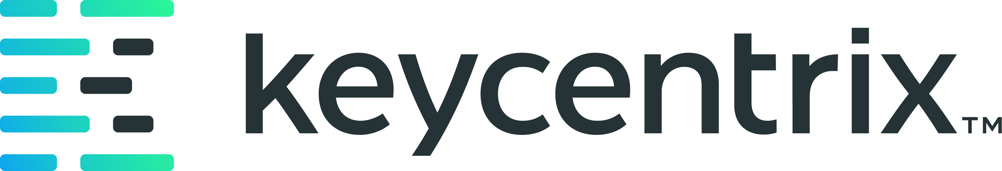
KCXDocumentor - Sample Generated Visual Guide - Newleaf Rx
Example generated guide packaged for executive review
Recipe alignment
Built as a keycentrix internal artifact using the KCX document standard: control metadata, version history, purpose, scope, audience, governance, process detail, and appendices.

Metadata Field | Document Value
Document ID | KCXDOC-SAMPLE-001
Version | 1.0
Effective Date | 2026-06-05
Status | Internal showcase sample
Owner | keycentrix Product and Training
Audience | Executive Team, Product, Training, Implementation, and Documentation Reviewers
Build Standard | KCX document standard

Package Notes
- The following pages are the generated guide output used to demonstrate KCXDocumentor capability.
- This front matter was added for the executive collateral package.
- The generated guide content remains available for review behind this package section.


Newleaf Rx Interfaces Overview
draft-1.0
keycentrix - Final Revision for Review
This guide explains the third-party interfaces available in Newleaf Rx, including electronic prescriptions, claim switches, prior authorization management, therapy management, robotics, communications, wholesaler ordering, point-of-sale systems, credit card processing, data and reporting, shipping and delivery, third-party reconciliation, and the Newleaf API.

Document Control Metadata
Metadata Field | Document Value
Owner | KCXDocumentor
Effective Date | 2026-06-05
Status | Final Revision for Review
Version | draft-1.0

Purpose
This guide explains the third-party interfaces available in Newleaf Rx, including electronic prescriptions, claim switches, prior authorization management, therapy management, robotics, communications, wholesaler ordering, point-of-sale systems, credit card processing, data and reporting, shipping and delivery, third-party reconciliation, and the Newleaf API.

Intended Audience
- Implementation team members
- Pharmacy workflow operators
- Trainers
- Support teams

Prerequisites
- Access to Newleaf Rx with appropriate user permissions.
- Familiarity with basic Newleaf Rx navigation.
- Interface credentials or enrollment completed by the implementation team for any interface being configured.

Workflow Overview
- Follow the workflow sections in order and confirm the expected screen or request status before moving to the next step.

Step-by-Step Procedures

eScripts and Switches

1. Understand the eScript Interface
Newleaf Rx interfaces with Surescripts for electronic prescriptions. Surescripts is the sole eScript provider within Newleaf Rx. Every pharmacy is enrolled with Surescripts, and all electronic prescriptions from prescribers are received through this interface.
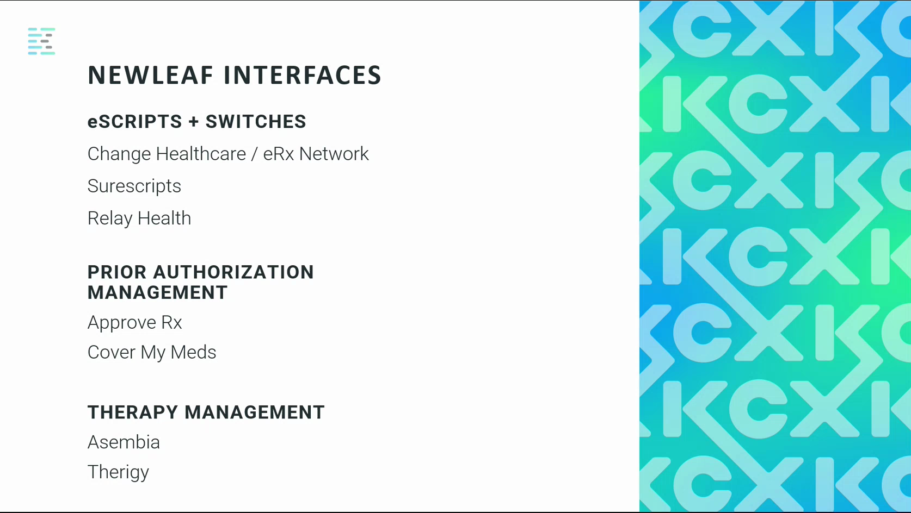

2. Understand Claim Switch Providers
A switch provider acts as a middleman for electronic claims. Every claim submitted from the pharmacy travels from Newleaf Rx to the switch provider, then on to the third-party payer. The response follows the same path in reverse. The two primary switch providers configured for Newleaf Rx pharmacies are Change Healthcare (also known as eRx Network) and Relay Health (also known as NDC). Additional switch providers are available, but these two are the standard setup for all pharmacies.
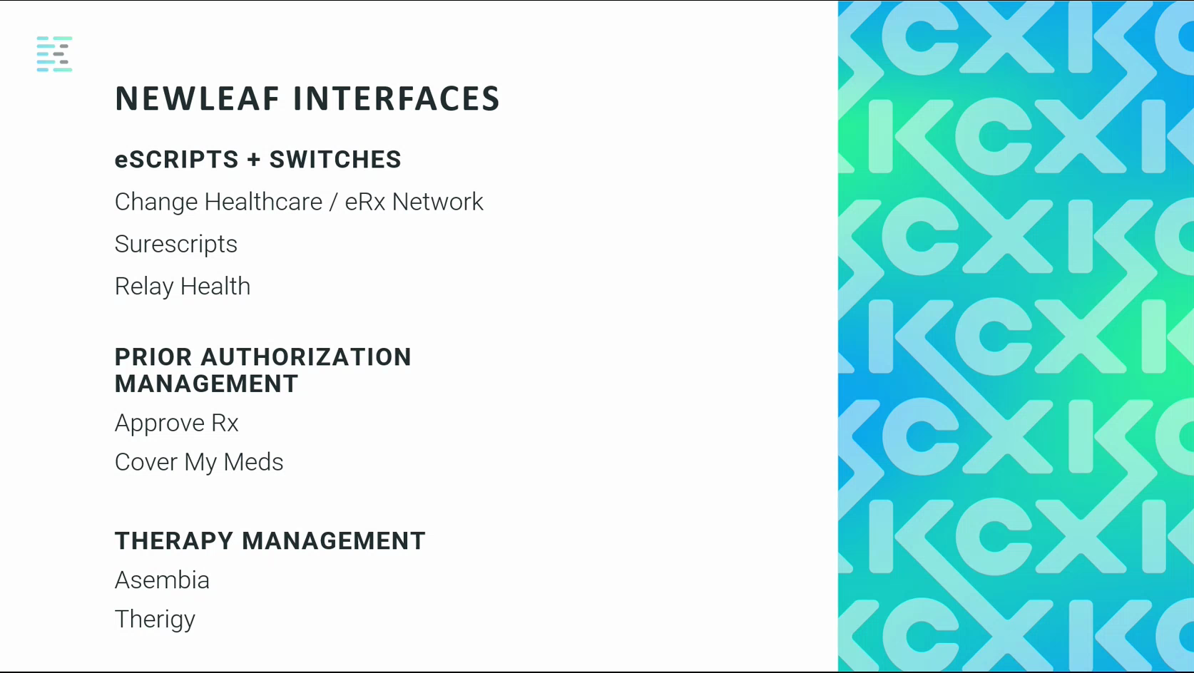

Prior Authorization Management

3. Understand Prior Authorization Interfaces
When a prescription requires a prior authorization from the insurance, Newleaf Rx provides two integrated options: Approve Rx and Cover My Meds. Both interfaces are accessible directly from within Newleaf Rx.
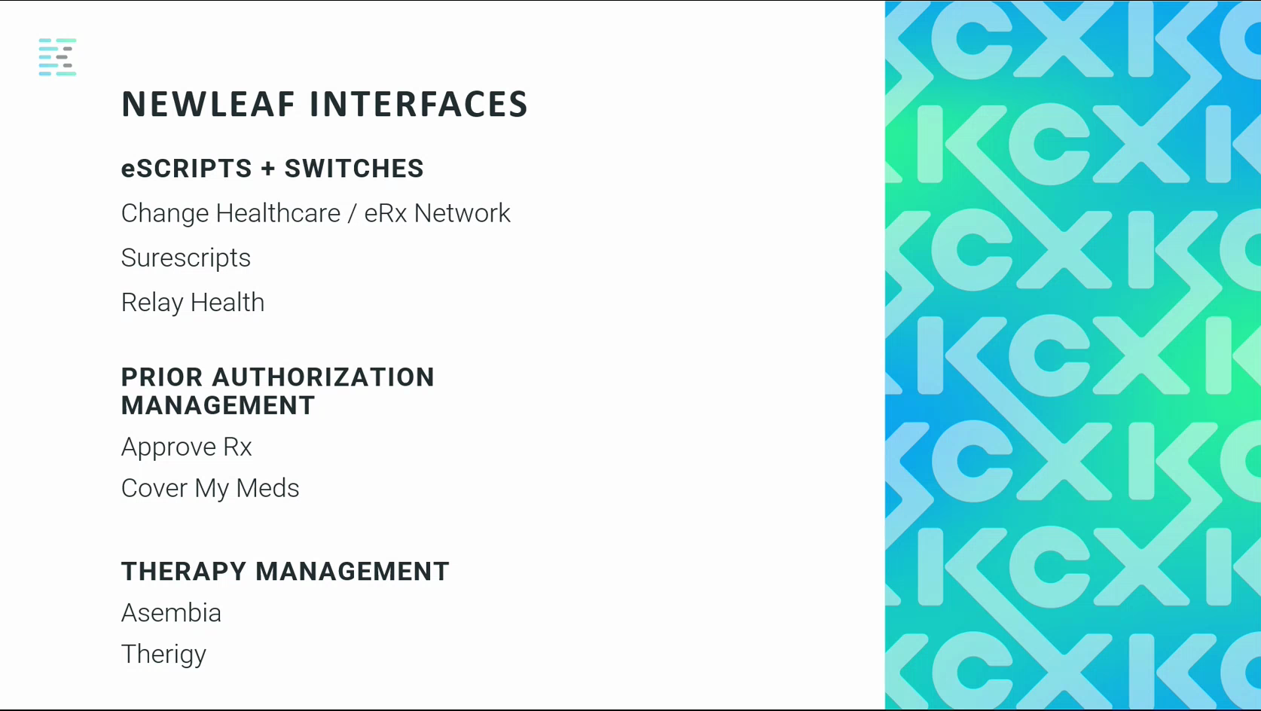

4. Submit a Prior Authorization from a Prescription
When a claim returns a rejection indicating that a prior authorization is required, right-click the prescription in Newleaf Rx and select either Cover My Meds or Approve Rx. This opens the selected application with most or all of the required information already populated. Review the pre-filled form, complete any remaining fields, and submit. The prior authorization service then manages the process with the insurance until the request is approved or denied. The final determination is returned to Newleaf Rx automatically.
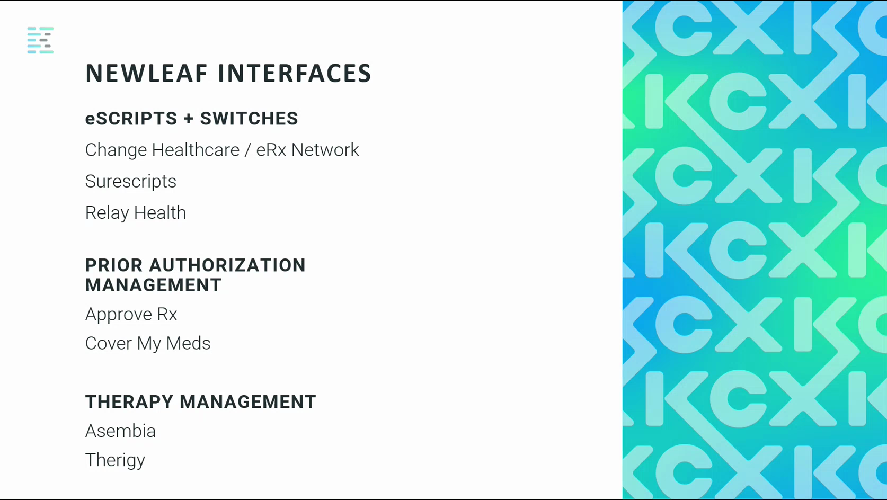

Therapy Management

5. Use the Therigy Interface
Newleaf Rx interfaces with Therigy for therapy management. The Therigy interface is the recommended option and is designed to support clinical activities for specific medications directly from within Newleaf Rx. From the scheduling area, select the clinical activity for the applicable medication. The interface guides you through each required form and collects all necessary information.
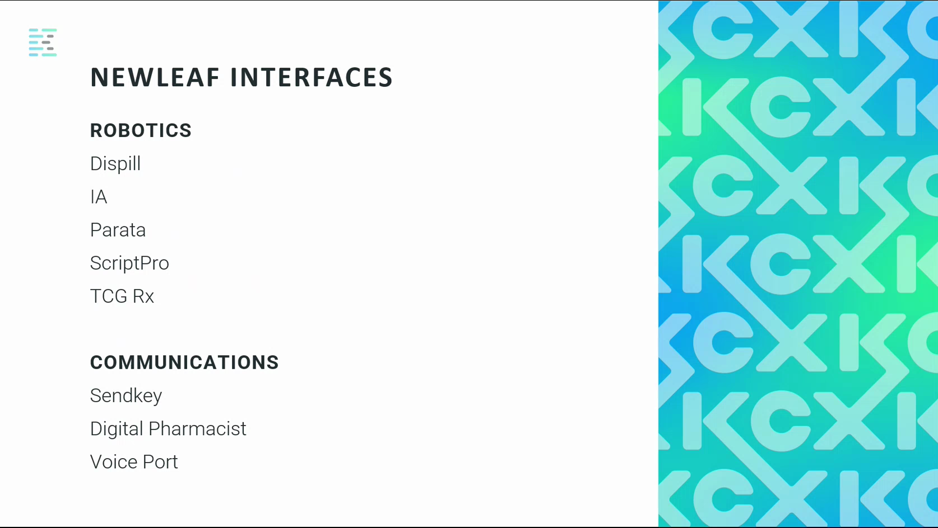

6. Understand the Asembia Interface
Newleaf Rx also interfaces with Asembia for therapy management. The Asembia interface is available for pharmacies that require it, though the Therigy interface is the primary recommendation.
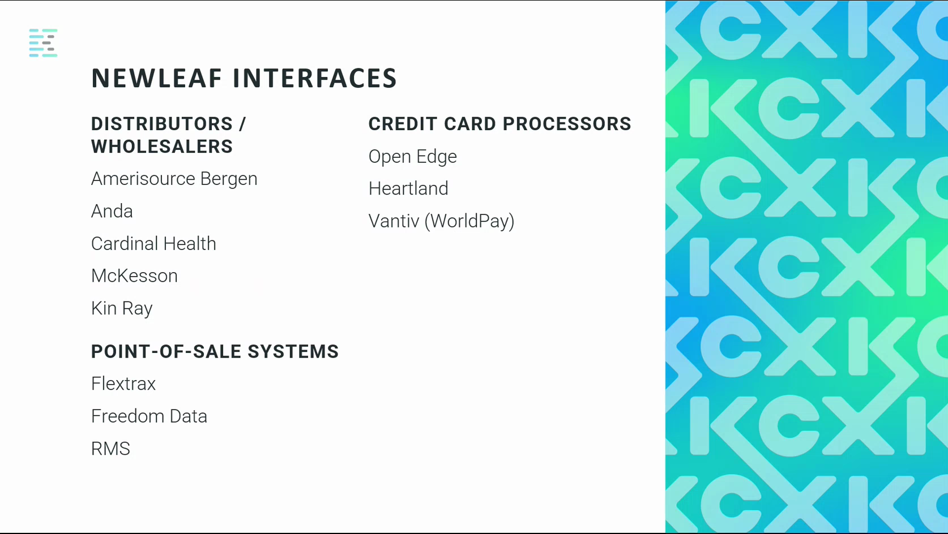

Robotics

7. Understand Robotics Interfaces
Newleaf Rx supports interfaces with dispensing and packaging robots. Supported robot systems include Dispill, IA, Parata, ScriptPro, TCG Rx, and Kirby Lester, among others. Only one robot interface can be active per pharmacy — multiple robot interfaces cannot be configured simultaneously.
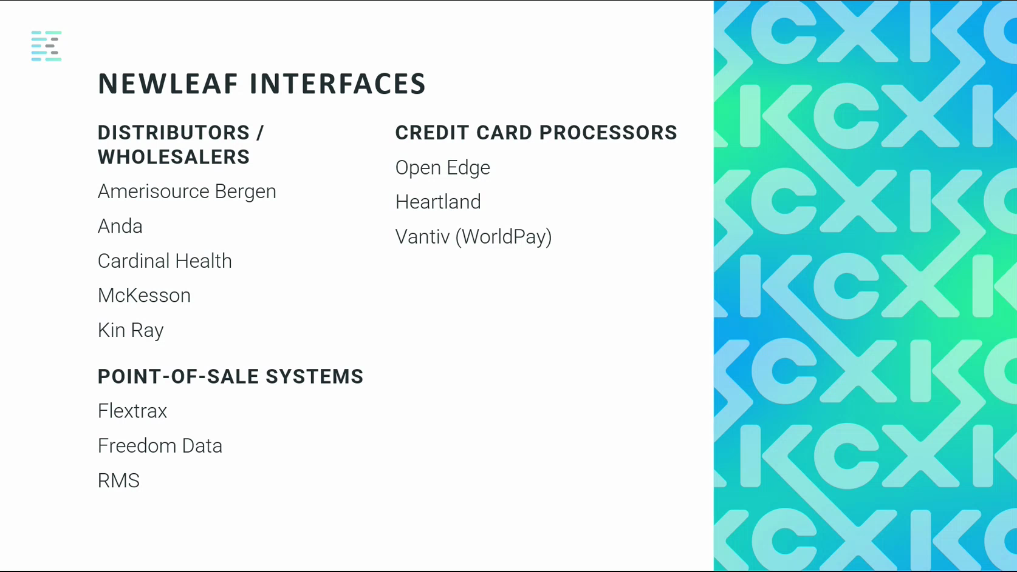

Communications

8. Use Sendkey for Patient Communications
Sendkey is the Centrix communication interface within Newleaf Rx. It enables pharmacies to communicate with patients through email, SMS text messaging, voice messages, and fax — all from within Newleaf Rx.
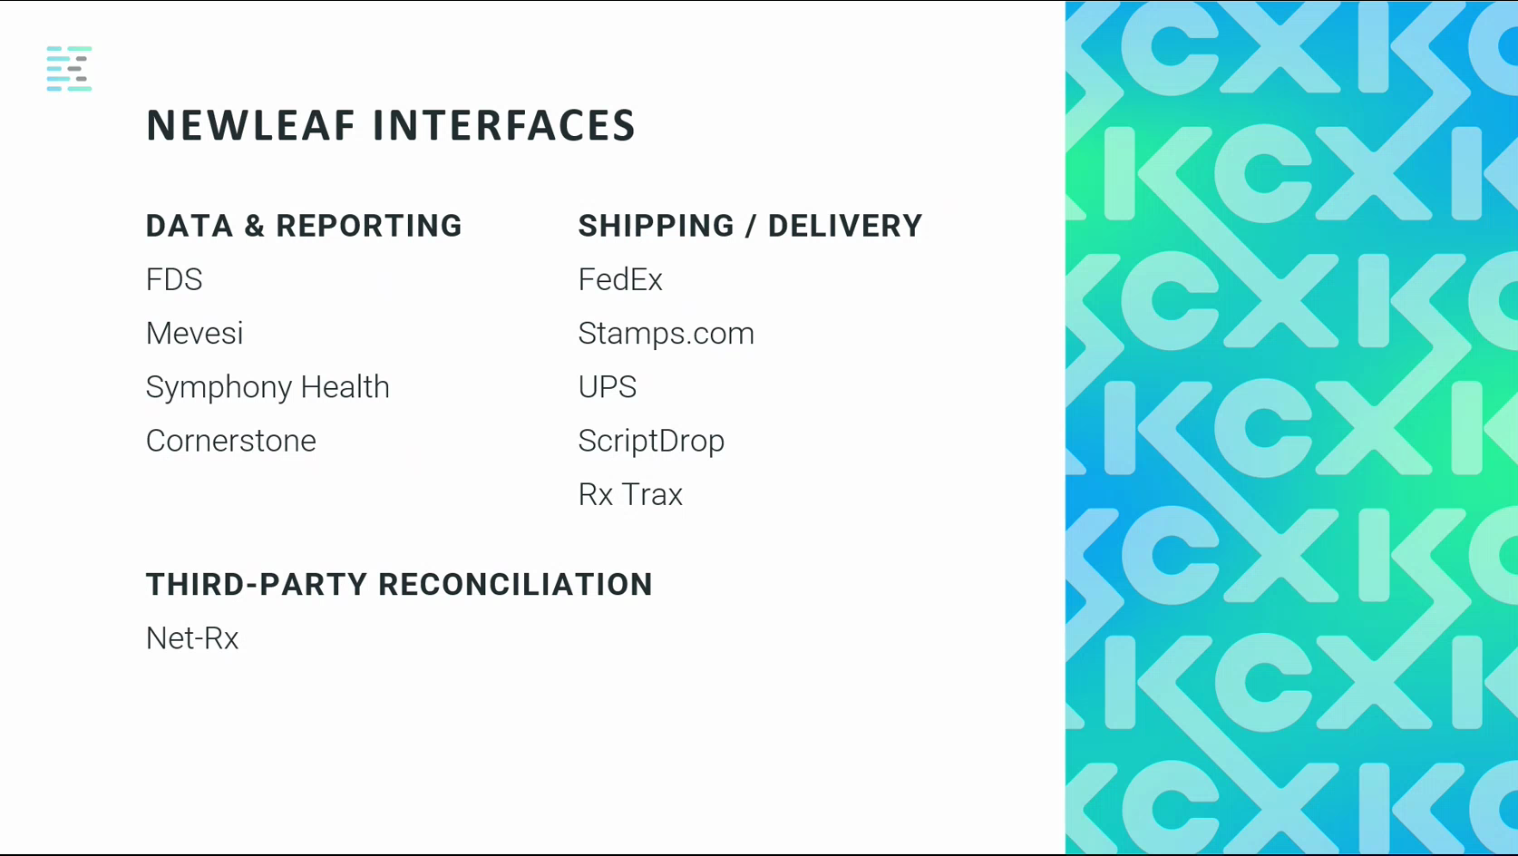

9. Understand IVR Interfaces
Digital Pharmacist and Voice Port are both interactive voice response (IVR) interfaces available within Newleaf Rx. These allow pharmacies to automate patient phone interactions.
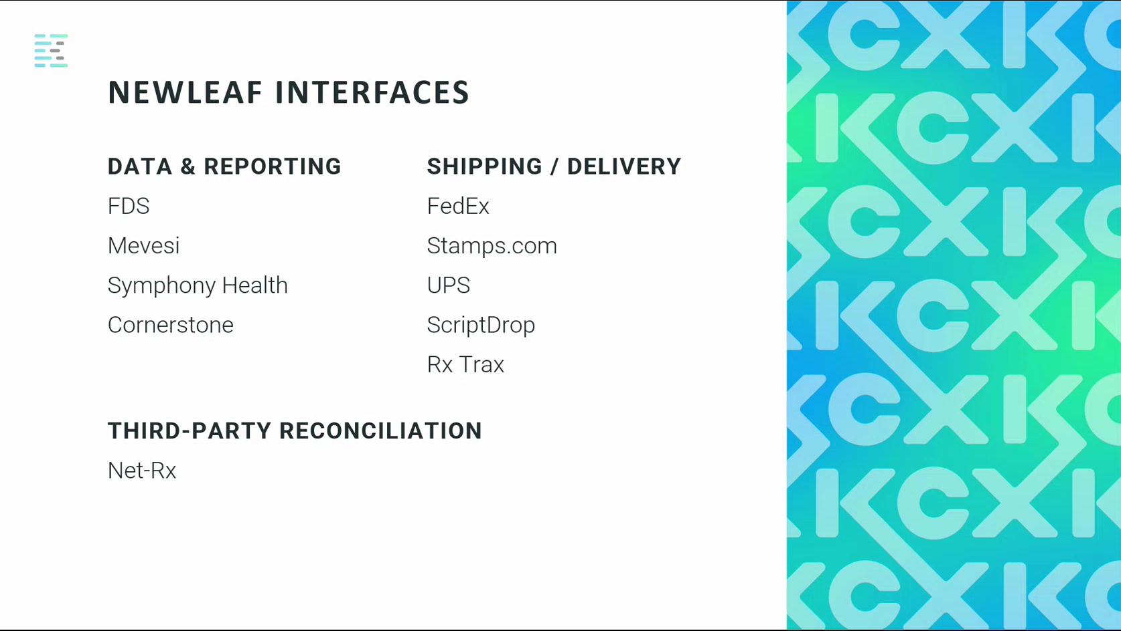

Wholesalers and Distributors

10. Understand Wholesaler Interfaces
Newleaf Rx interfaces with major pharmaceutical wholesalers and distributors, including Amerisource Bergen (also known as ABC or AMS), Cardinal Health, McKesson, Kinray, and HD Smith, among others. These interfaces allow pharmacies to submit medication orders electronically to their wholesalers directly from within Newleaf Rx. Wholesalers can also send back order confirmations, including information about items that are shorted or unavailable.
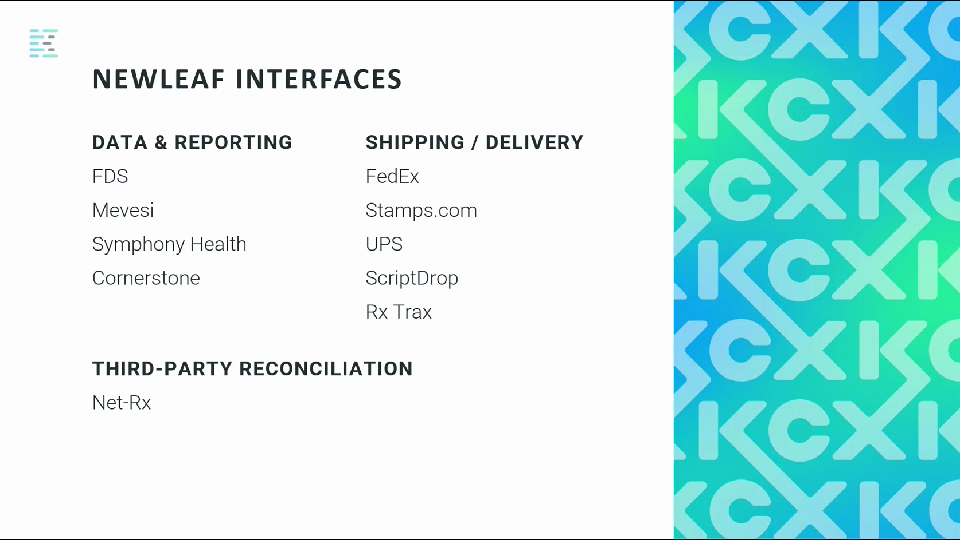

11. Create and Send an Electronic Purchase Order
To submit an order electronically to a wholesaler, navigate to F4 Inventory, then select F1 Purchase Order. Create a new purchase order, add the required items, and send the order electronically to the wholesaler. The wholesaler's response, including any shorted items, is returned electronically to Newleaf Rx.


Point-of-Sale Systems

12. Understand Point-of-Sale Interfaces
Newleaf Rx interfaces with three point-of-sale systems: Flextrax, Freedom Data, and RMS. Flextrax is a Centrix product.
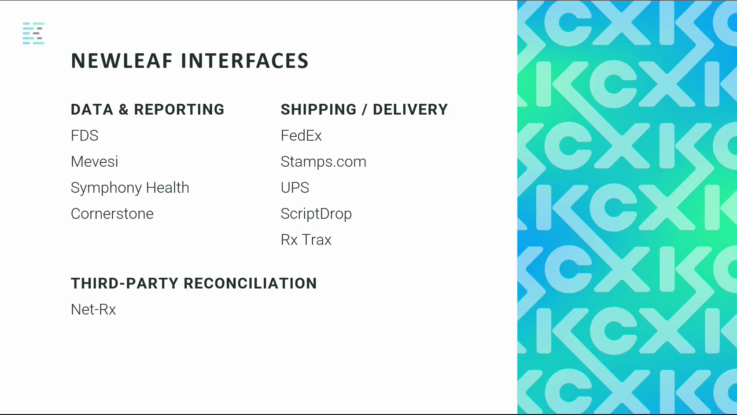

Credit Card Processors

13. Understand Credit Card Processing Interfaces
Newleaf Rx supports two credit card processors: Heartland and Vantiv (also known as WorldPay or Element). Heartland can be used in both Flextrax and Newleaf Rx. Vantiv is available in Newleaf Rx only. Open Edge is available through Flextrax only and is not a direct Newleaf Rx interface.
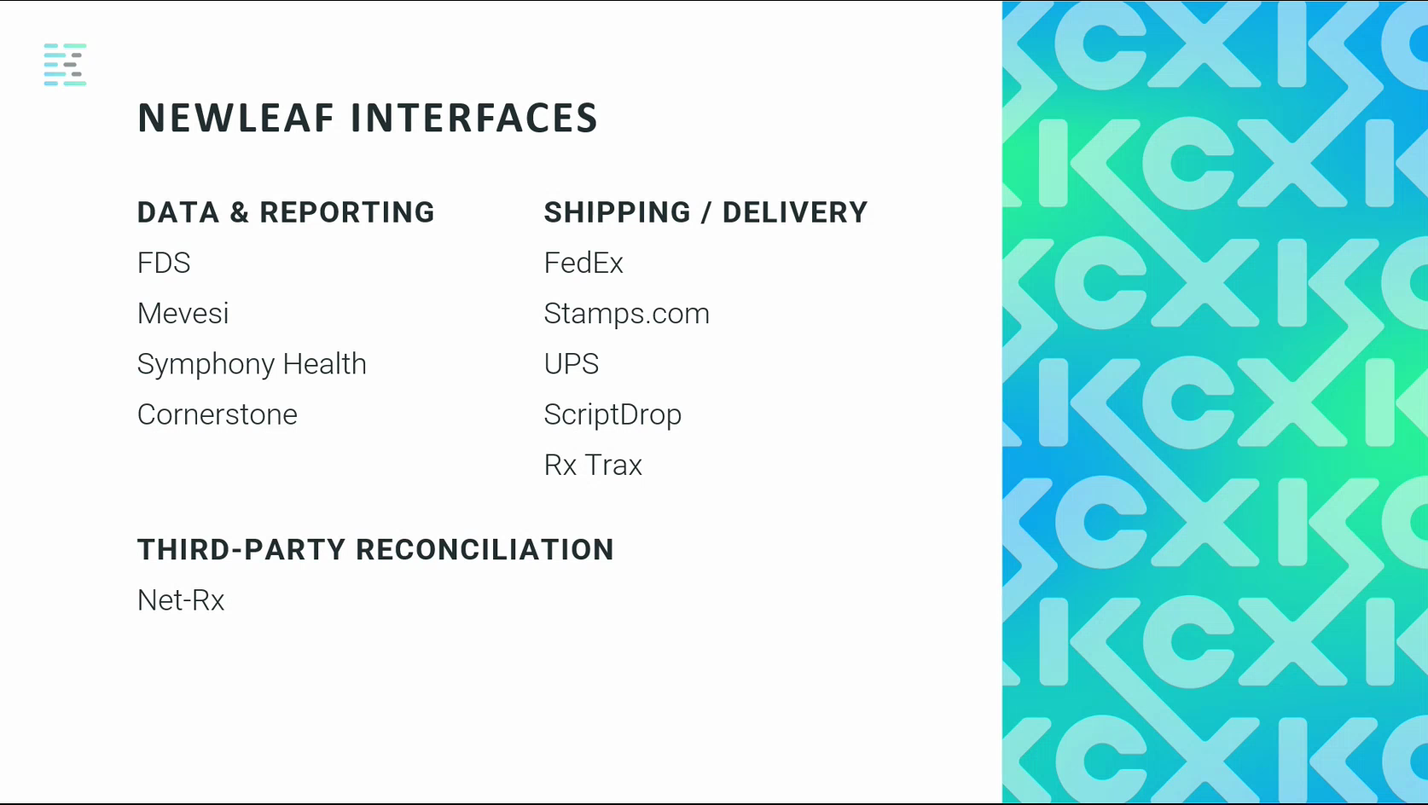

Data and Reporting

14. Understand Data and Reporting Interfaces
Newleaf Rx can be configured to automatically send pharmacy data to reporting partners. Supported interfaces include FDS, Mevesi, Symphony Health, and Cornerstone. These integrations help pharmacies qualify for wholesaler discounts and meet reporting obligations. Data is transmitted automatically once the interface is configured.


Third-Party Reconciliation

15. Understand the Net-Rx Interface
Net-Rx is the third-party reconciliation interface in Newleaf Rx. When configured, Net-Rx receives an Explanation of Benefits (EOB) from the insurance for all claims submitted to third-party payers. Net-Rx matches those EOB payments against the claims submitted in Newleaf Rx.


16. Apply Third-Party Reconciliation Payments
To process a Net-Rx reconciliation, navigate to F3 A/R and then select the Post Payment option. Use the Auto-Reconcile function to pull in the matched payment data from Net-Rx. Review any claims where the expected payment differs from the actual payment received. For any difference, you can write off the variance using the write-off option. The reconciliation cannot be completed until the balance reaches zero — there can be no remaining over or under amount. Once the balance is zero, apply the payment to complete the reconciliation.
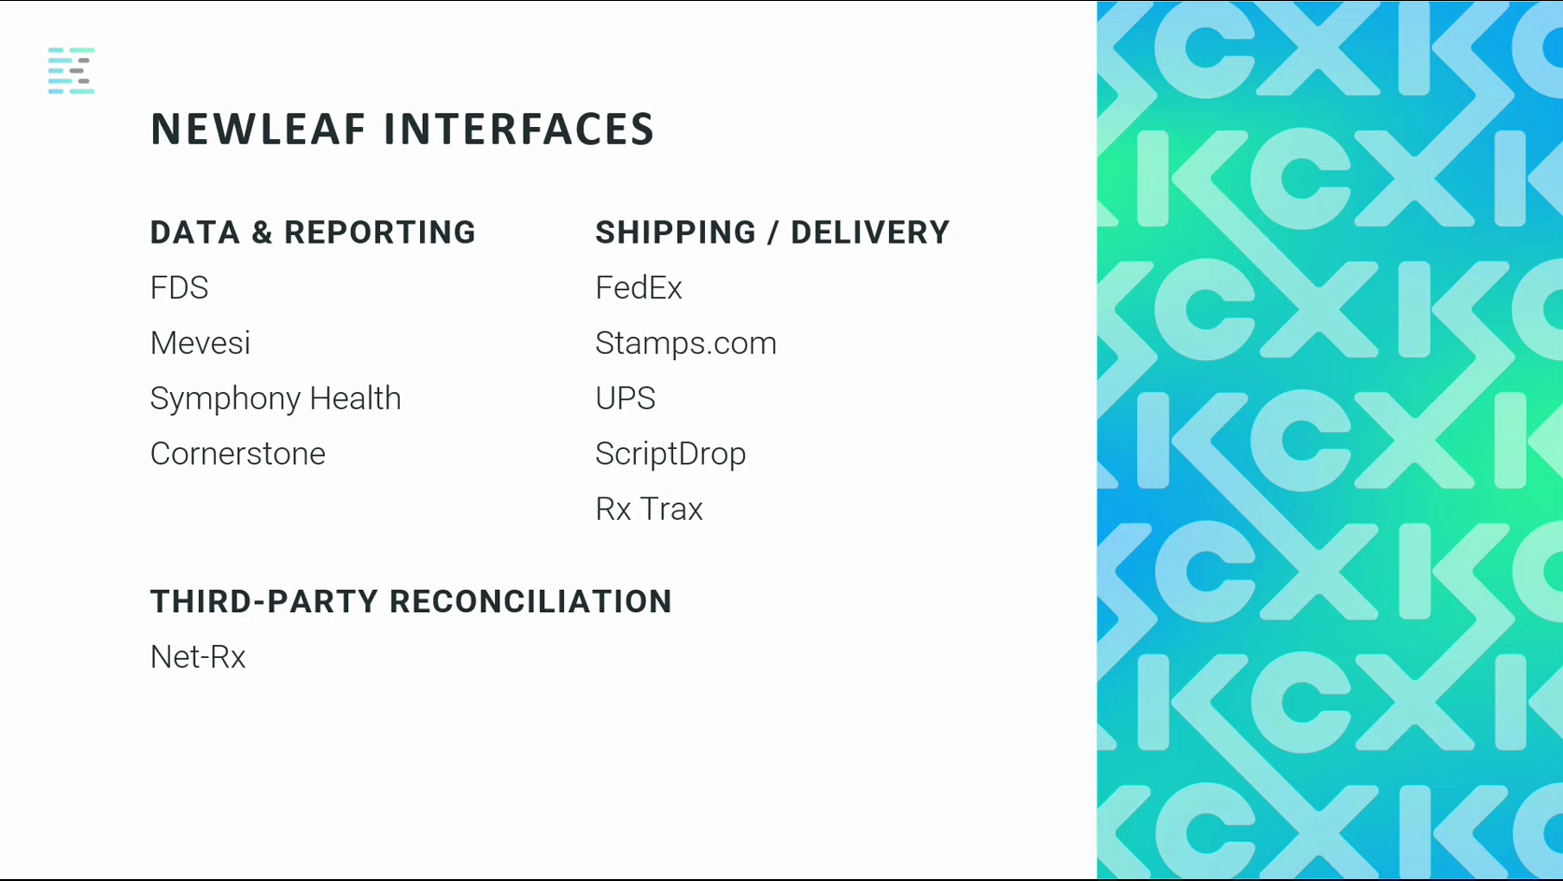

Shipping and Delivery

17. Understand Shipping Interface Options
Newleaf Rx offers two types of shipping connectivity. A direct interface is available for FedEx and ScriptDrop. An ODBC connection can be configured for FedEx, Stamps.com, and UPS, but this requires the pharmacy to have the corresponding shipping application installed and to complete the shipping label process from within that external application.
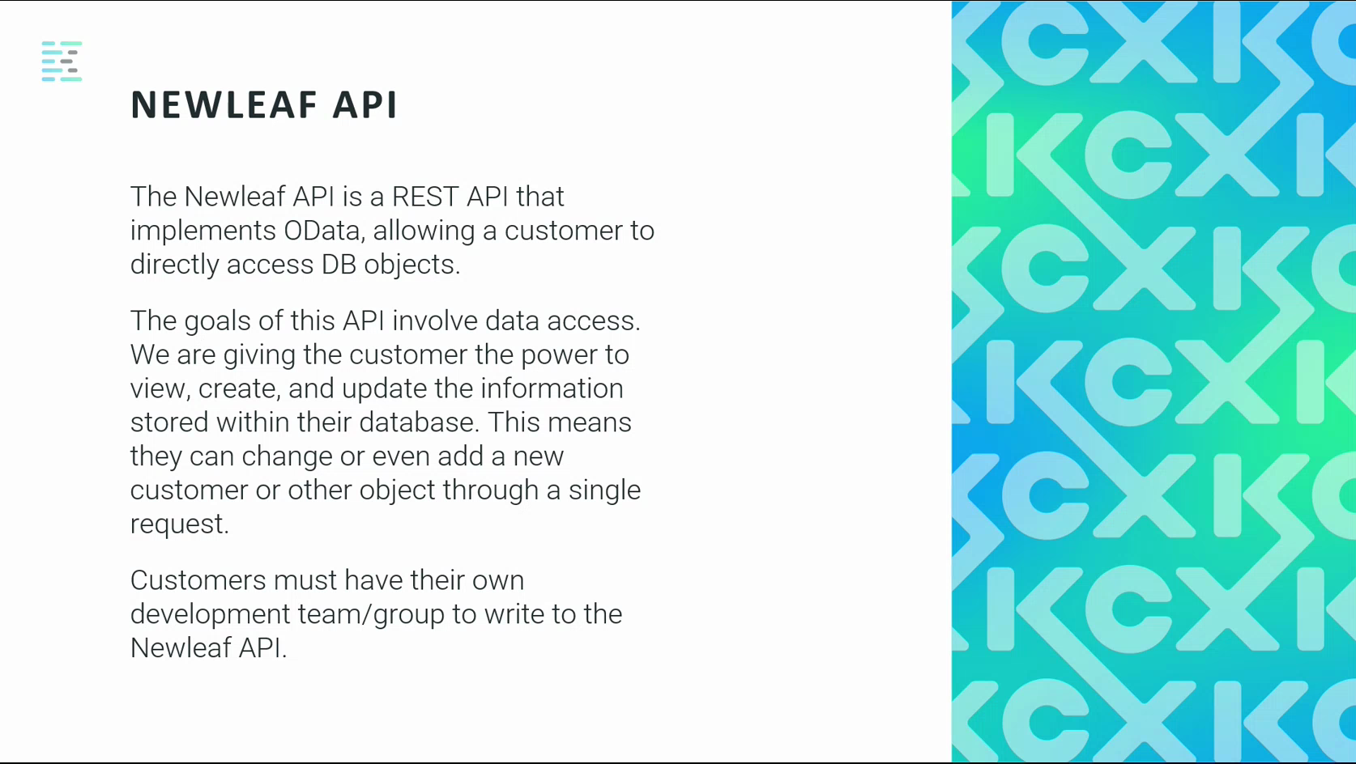

18. Use the ScriptDrop Interface
The ScriptDrop interface allows the pharmacy to manage the entire shipping process from within Newleaf Rx without requiring any external shipping application. ScriptDrop supports FedEx, UPS, and USPS. The pharmacy can use one, two, or all three carriers. Shipping labels are generated and printed directly from Newleaf Rx.
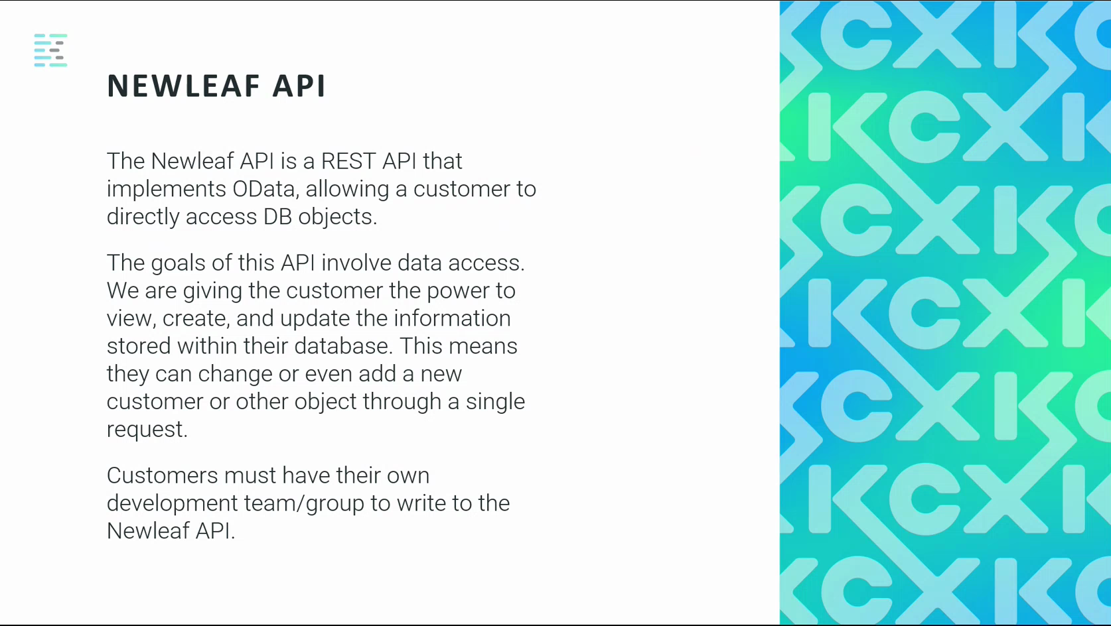

19. Use the Rx Trax Local Delivery Interface
Rx Trax is a delivery interface for pharmacies that use their own delivery drivers for local deliveries. When configured, Rx Trax collects all scheduled deliveries and maps the most efficient delivery route, reducing unnecessary travel time and cost. The pharmacy's delivery driver follows the optimized route generated by the interface.


Newleaf API

20. Understand the Newleaf API
The Newleaf API is a REST API that implements OData, giving customers direct access to their Newleaf Rx database objects. Through the API, customers can view, create, and update information stored in their database. Customers are responsible for all development work required to write to the API. Newleaf provides access to the API and supporting reference materials, but does not write custom development on behalf of the customer. Customers must have their own developer or development team.
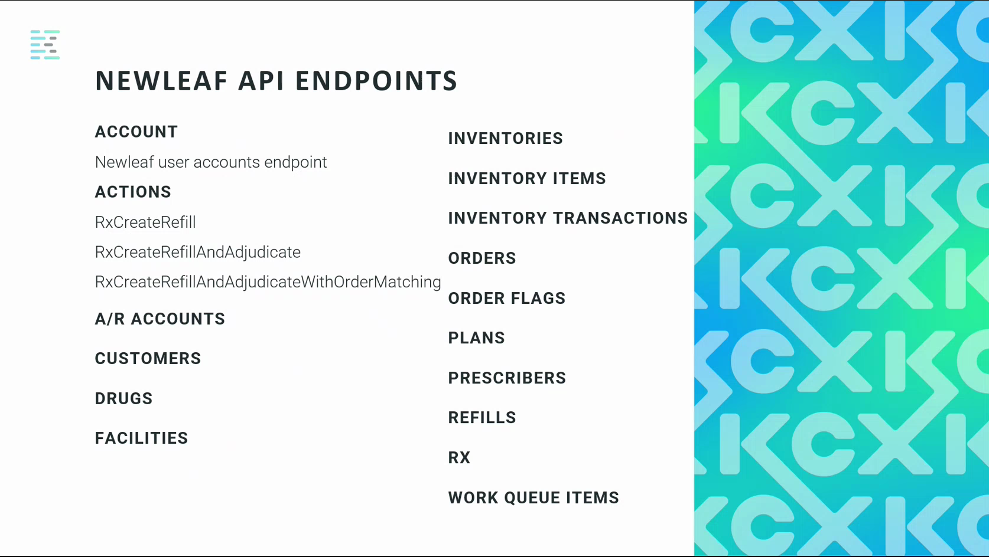

21. Review Available API Endpoints
The Newleaf API exposes endpoints across multiple functional areas. Available endpoint categories include: Account, Inventories, Inventory Items, Inventory Transactions, Orders, Order Flags, A/R Accounts, Plans, Customers, Prescribers, Drugs, Refills, Facilities, and RX Work Queue Items. Available actions include RxCreateRefill, RxCreateRefillAndAdjudicate, and RxCreateRefillAndAdjudicateWithOrderMatching.
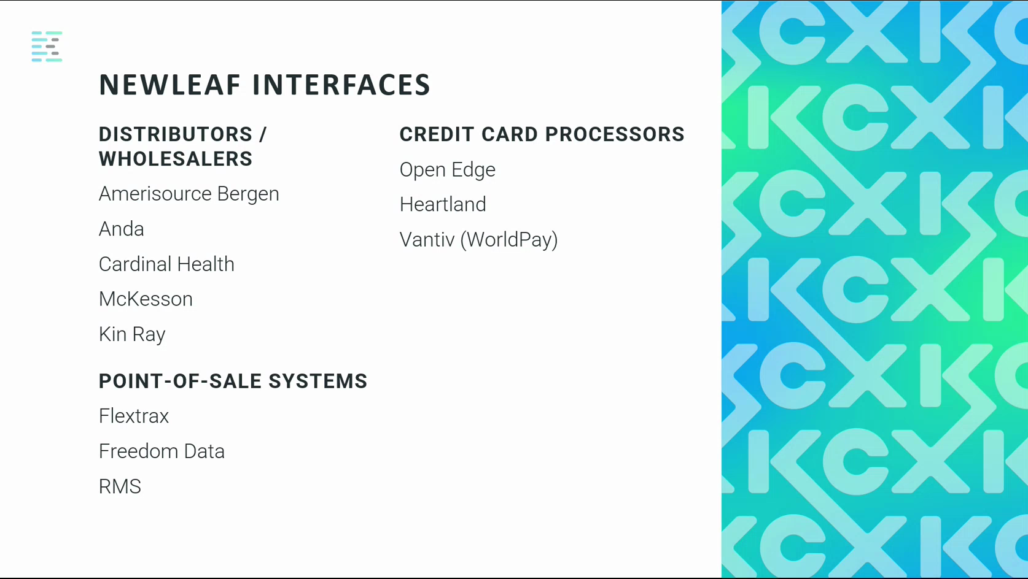

Expected Results
- The user can complete the documented workflow and confirm the expected request or configuration outcome.

Troubleshooting Notes
- If the workflow does not match the current application behavior, confirm the current process with the appropriate application owner.

Appendix: Source Recording Metadata

Document Control Metadata
Metadata Field | Document Value
Application | Newleaf Rx
Recording Duration | Not specified
Recorded At | Not specified
Source Recording | {'captureDate': '2022-07-26', 'durationSeconds': 868.736, 'sourceName': '11_KCX Bootcamp-Newleaf Interfaces-20220726_103459-Meeting Recording.mp4'}
Input File | /Users/djames/Documents/AppDev/KCXDocumentor/artifacts/generated/newleaf-rx-visual-guide-fresh/guide_draft.anthropic.json

